**DAILY ONLINE ACTIVITIES SUMMARY**

|  |  |  |  |  |  |  |  |  |
| --- | --- | --- | --- | --- | --- | --- | --- | --- |
| **Date:** | **10-06-2020** | | | | | **Name:** | **Anusha** | |
| **Sem & Sec** | **VIII Semester & A Section** | | | | | **USN:** | **4AL16CS014** | |
| **Online Test Summary** | | | | | | | | |
| **Subject** | | **NO TEST WAS CONDUCTED** | | | | | | |
| **Max. Marks** | | **-** | | **Score** | | | **-** | |
| **Certification Course Summary** | | | | | | | | |
| **Course** | **Introduction to Hadoop 3.0** | | | | | | | |
| **Certificate Provider** | | | **Great Learning** | | **Duration** | | | **3 Hours** |
| **Coding Challenges** | | | | | | | | |
| **Problem Statement: Write a program for matrix boundary** | | | | | | | | |
| **Status: COMPLETED** | | | | | | | | |
| **Uploaded the report in Github** | | | | | **YES** | | | |
| **If yes Repository name** | | | | | **anushasuvarna-014** | | | |
| **Uploaded the report in slack** | | | | | **YES** | | | |

Online Test Details:

NIL

Certification Course Details:

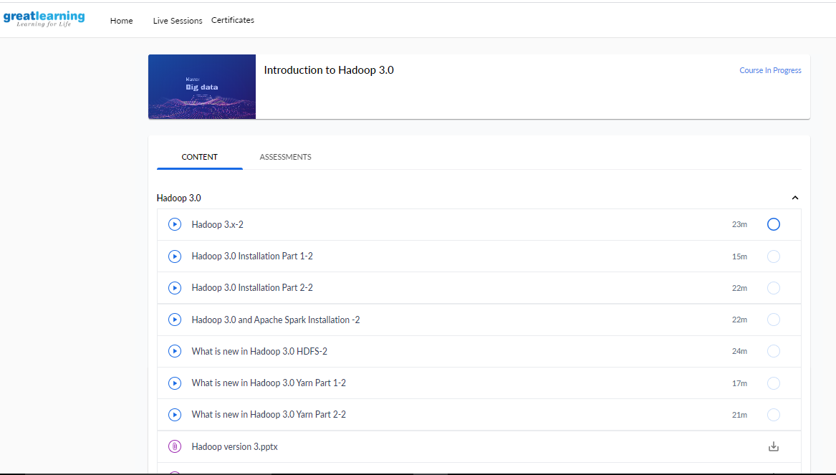

Coding Challenges Details:

|  |
| --- |
|  |
|  |
|  |
|  |
|  |
|  |
|  |
|  |
|  |
|  |
|  |
|  |
|  |
|  |
|  |
|  |
|  |
|  |
|  |
|  |
|  |
|  |
|  |
|  |
|  |
|  |
|  |
|  |
|  |
|  |
|  |
|  |
|  |
|  |
|  |
|  |
|  |
|  |
|  |
|  |
|  |
|  |
|  |
|  |
|  |
|  |
|  |
|  |
|  |
|  |
|  |
|  |
|  |
|  |

**Program1:**

|  |
| --- |
| **#include<stdio.h>** |
|  |  |
|  | **void main()** |
|  | **{** |
|  | **int arr[10][10], i, j, m, n, sum = 0;** |
|  |  |
|  | **printf("Enter M rows and N columns: ");** |
|  | **scanf("%d%d", &m, &n);** |
|  |  |
|  | **printf("Enter the elements:\n");** |
|  | **for(i = 0; i < m; i++)** |
|  | **for(j = 0; j < n; j++)** |
|  | **scanf("%d", &arr[i][j]);** |
|  |  |
|  | **printf("The input matrix is:\n");** |
|  | **for(i = 0; i < m; i++)** |
|  | **{** |
|  | **for(j = 0; j < n; j++)** |
|  | **printf("%d ", arr[i][j]);** |
|  | **printf("\n");** |
|  | **}** |
|  |  |
|  | **printf("The boundary elements are: ");** |
|  | **for(j = 0; j < n; j++)** |
|  | **printf("%d ", arr[0][j]);** |
|  | **for(i = 1; i < m - 1; i++)** |
|  | **for(j = 0; j < n; j++)** |
|  | **{** |
|  | **if(j == 0 || j == n-1)** |
|  | **printf("%d ", arr[i][j]);** |
|  | **}** |
|  | **for(j = 0; j < n; j++)** |
|  | **printf("%d ", arr[m-1][j]);** |
|  |  |
|  | **for(j = 0; j < n; j++)** |
|  | **sum += arr[0][j];** |
|  | **for(i = 1; i < m - 1; i++)** |
|  | **for(j = 0; j < n; j++)** |
|  | **{** |
|  | **if(j == 0 || j == n-1)** |
|  | **sum += arr[i][j];** |
|  | **}** |
|  | **for(j = 0; j < n; j++)** |
|  | **sum += arr[m-1][j];** |
|  |  |
|  | **printf("\nThe sum of boundary elements of the matrix is: %d\n", sum);** |
|  | **}** |